Dokumentasi Praktikum PBO 13

Mata Kuliah : PBO - TI - S1

Pertemuan : 13

NIM : A11.2021.13254

Nama : Yohanes Dimas Pratama

**Program Laporan dengan iReport**

Hasil Program:

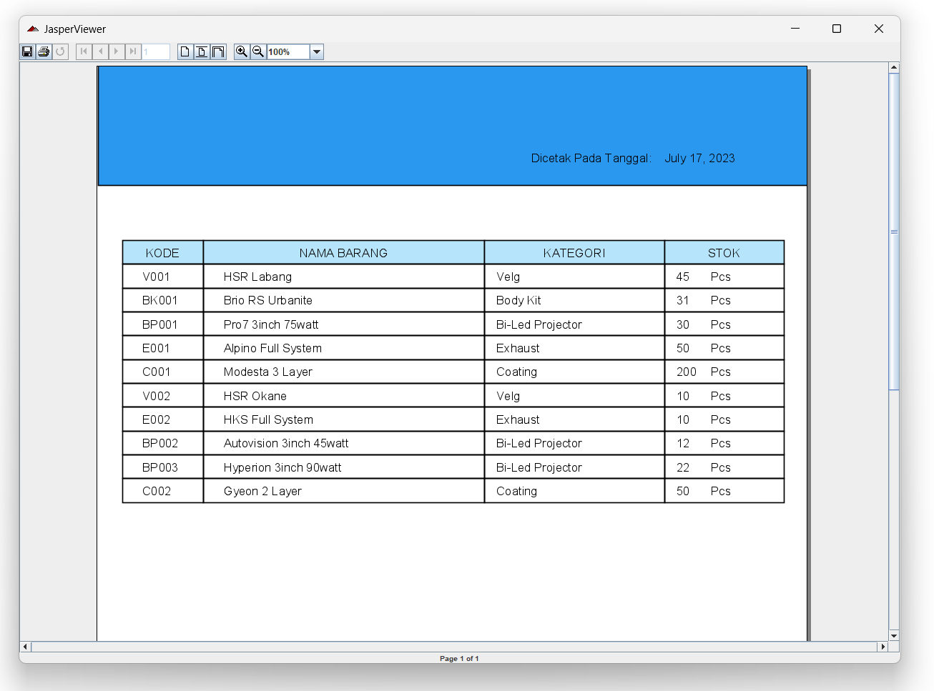

Code Program:

*Form_Laporan.java

private void btncetakActionPerformed(java.awt.event.ActionEvent evt) {

String id_laporan = cmbid_laporan.getSelectedItem().toString();

switch (id_laporan) {

case "Pilih":

JOptionPane.showMessageDialog(null, "Terdapat inputan yang kosong.");

break;

case "Data Barang":

try {

File file = new File("src/report/report_barang.jrxml");

JasperDesign jasperDesign = JRXmlLoader.load(file);

JasperReport jasperReport = JasperCompileManager.compileReport(jasperDesign);

JasperPrint jasperPrint = JasperFillManager.fillReport(jasperReport, null, konek.openkoneksi());

JasperViewer.viewReport(jasperPrint, false);

} catch (ClassNotFoundException | JRException e) {

JOptionPane.showMessageDialog(null, "Error " + e);

}

this.hide();

break;

default:

SimpleDateFormat date;

date = new SimpleDateFormat("yyyy-MM-dd");

String d_dari = date.format(txtd_dari.getDate());

String d_sampai = date.format(txtd_sampai.getDate());

if (id_laporan.equals("Transaksi Barang Masuk")) {

try {

HashMap hash = new HashMap();

hash.put("d_dari", d_dari);

hash.put("d_sampai", d_sampai);

File file1 = new File("src/report/report_barangMasuk.jrxml");

JasperDesign jasperDesign = JRXmlLoader.load(file1);

JasperReport jasperReport = JasperCompileManager.compileReport(jasperDesign);

JasperPrint jasperPrint = JasperFillManager.fillReport(jasperReport, hash, konek.openkoneksi());

JasperViewer.viewReport(jasperPrint, false);

} catch (ClassNotFoundException | JRException e) {

JOptionPane.showMessageDialog(null, "Error " + e);

}

} else if (id_laporan.equals("Transaksi Barang Keluar")) {

try {

HashMap hash = new HashMap();

hash.put("d_dari", d_dari);

hash.put("d_sampai", d_sampai);

File file2 = new File("src/report/report_barangKeluar.jrxml");

JasperDesign jasperDesign = JRXmlLoader.load(file2);

JasperReport jasperReport = JasperCompileManager.compileReport(jasperDesign);

JasperPrint jasperPrint = JasperFillManager.fillReport(jasperReport, hash, konek.openkoneksi());

JasperViewer.viewReport(jasperPrint, false);

} catch (ClassNotFoundException | JRException e) {

JOptionPane.showMessageDialog(null, "Error " + e);

}

}

this.hide();

break;

}

}

*report_barang.jrxml

<?xml version="1.0" encoding="UTF-8"?>

<jasperReport xmlns="http://jasperreports.sourceforge.net/jasperreports" xmlns:xsi="http://www.w3.org/2001/XMLSchema-instance" xsi:schemaLocation="http://jasperreports.sourceforge.net/jasperreports http://jasperreports.sourceforge.net/xsd/jasperreport.xsd" name="null" language="groovy" pageWidth="595" pageHeight="842" columnWidth="555" leftMargin="20" rightMargin="20" topMargin="20" bottomMargin="20" uuid="c134c83c-726b-4f18-bba9-f55c2b30941b">

<property name="ireport.zoom" value="1.0"/>

<property name="ireport.x" value="0"/>

<property name="ireport.y" value="0"/>

<queryString>

<![CDATA[SELECT tmbarang.id, tmbarang.kode, tmbarang.nama, tmbarang.satuan, tmbarang.stok, tmkategori.nama as nama_kategori FROM tmbarang JOIN tmkategori ON tmkategori.id = tmbarang.id_kategori]]>

</queryString>

<field name="id" class="java.lang.Integer">

<fieldDescription><![CDATA[]]></fieldDescription>

</field>

<field name="kode" class="java.lang.String">

<fieldDescription><![CDATA[]]></fieldDescription>

</field>

<field name="nama" class="java.lang.String">

<fieldDescription><![CDATA[]]></fieldDescription>

</field>

<field name="satuan" class="java.lang.String">

<fieldDescription><![CDATA[]]></fieldDescription>

</field>

<field name="stok" class="java.lang.Integer">

<fieldDescription><![CDATA[]]></fieldDescription>

</field>

<field name="nama_kategori" class="java.lang.String"/>

<group name="nama">

<groupExpression><![CDATA[$F{nama}]]></groupExpression>

</group>

<group name="satuan">

<groupExpression><![CDATA[$F{satuan}]]></groupExpression>

</group>

<group name="stok">

<groupExpression><![CDATA[$F{stok}]]></groupExpression>

</group>

<group name="nama_kategori">

<groupExpression><![CDATA[$F{nama_kategori}]]></groupExpression>

</group>

<background>

<band splitType="Stretch"/>

</background>

<title>

<band height="79" splitType="Stretch">

<rectangle>

<reportElement x="-20" y="-24" width="599" height="103" backcolor="#2B98F0" uuid="c541bfc5-187b-48b9-9980-681957e9d566"/>

</rectangle>

<staticText>

<reportElement x="0" y="42" width="226" height="27" forecolor="#B6E5FB" uuid="a8db9c42-686e-461e-93ad-5060da862fbc"/>

<textElement>

<font size="22"/>

</textElement>

<text><![CDATA[INVENTORI BARANG]]></text>

</staticText>

<textField pattern="MMMMM dd, yyyy">

<reportElement x="455" y="49" width="100" height="20" uuid="21a69f0b-a5d7-428a-b726-621df158118b"/>

<textFieldExpression><![CDATA[new java.util.Date()]]></textFieldExpression>

</textField>

<staticText>

<reportElement x="343" y="49" width="112" height="20" uuid="c24561b5-cea6-41a9-be72-0d001111dcc7"/>

<text><![CDATA[Dicetak Pada Tanggal:]]></text>

</staticText>

</band>

</title>

<pageHeader>

<band height="36" splitType="Stretch">

<staticText>

<reportElement x="175" y="11" width="240" height="25" uuid="3a25319d-aabe-4929-a4fc-58d3fcefac40"/>

<textElement>

<font fontName="SansSerif" size="20"/>

</textElement>

<text><![CDATA[Report Persedian Barang]]></text>

</staticText>

</band>

</pageHeader>

<columnHeader>

<band height="30" splitType="Stretch">

<rectangle>

<reportElement mode="Opaque" x="0" y="10" width="68" height="20" backcolor="#B6E5FB" uuid="765dff47-d9a6-46f4-bafe-904ad6224c93"/>

</rectangle>

<staticText>

<reportElement x="0" y="10" width="68" height="20" backcolor="#B6E5FB" uuid="94463579-3842-4bc8-8e52-91bf37651441"/>

<textElement textAlignment="Center" verticalAlignment="Middle"/>

<text><![CDATA[KODE]]></text>

</staticText>

<rectangle>

<reportElement x="68" y="10" width="236" height="20" backcolor="#B6E5FB" uuid="60ea7e73-403f-4ecc-9dfd-aff2c593227d"/>

</rectangle>

<staticText>

<reportElement x="68" y="10" width="236" height="20" backcolor="#B6E5FB" uuid="1dac0558-d146-40fa-b98f-314934174f61"/>

<textElement textAlignment="Center" verticalAlignment="Middle"/>

<text><![CDATA[NAMA BARANG]]></text>

</staticText>

<rectangle>

<reportElement x="304" y="10" width="151" height="20" backcolor="#B6E5FB" uuid="c179f7d4-ea96-48f8-b3a7-c45bf47526af"/>

</rectangle>

<staticText>

<reportElement x="304" y="10" width="151" height="20" backcolor="#B6E5FB" uuid="27f892f9-6f3b-44d9-92e9-64b9fe0c6d47"/>

<textElement textAlignment="Center" verticalAlignment="Middle"/>

<text><![CDATA[KATEGORI]]></text>

</staticText>

<rectangle>

<reportElement x="455" y="10" width="100" height="20" backcolor="#B6E5FB" uuid="a65767bd-e73f-4a1a-8d6b-693f97cf491e"/>

</rectangle>

<staticText>

<reportElement x="455" y="10" width="100" height="20" backcolor="#B6E5FB" uuid="80cc1f84-3ec8-42d2-a93a-dd7761a65e0d"/>

<textElement textAlignment="Center" verticalAlignment="Middle"/>

<text><![CDATA[STOK]]></text>

</staticText>

</band>

</columnHeader>

<detail>

<band height="20" splitType="Stretch">

<textField>

<reportElement x="85" y="0" width="219" height="20" uuid="83e2ec43-472e-40a3-beed-443346a3402f"/>

<textElement verticalAlignment="Middle"/>

<textFieldExpression><![CDATA[$F{nama}]]></textFieldExpression>

</textField>

<textField>

<reportElement x="314" y="0" width="141" height="20" uuid="e63e1cdc-84da-4bdb-9795-5100b004a3ed"/>

<textElement verticalAlignment="Middle"/>

<textFieldExpression><![CDATA[$F{nama_kategori}]]></textFieldExpression>

</textField>

<textField>

<reportElement x="465" y="0" width="29" height="20" uuid="66843d22-7461-48ea-8cf9-5aed20510041"/>

<textElement verticalAlignment="Middle"/>

<textFieldExpression><![CDATA[$F{stok}]]></textFieldExpression>

</textField>

<textField>

<reportElement x="494" y="0" width="61" height="20" uuid="87389b0a-ae80-4b8c-bc4a-a109ab2ef536"/>

<textElement verticalAlignment="Middle"/>

<textFieldExpression><![CDATA[$F{satuan}]]></textFieldExpression>

</textField>

<textField>

<reportElement x="17" y="0" width="68" height="20" uuid="d6c743ce-74c0-4072-8c17-185131cb983c"/>

<textElement textAlignment="Left" verticalAlignment="Middle"/>

<textFieldExpression><![CDATA[$F{kode}]]></textFieldExpression>

</textField>

<rectangle>

<reportElement mode="Transparent" x="0" y="0" width="68" height="20" uuid="e9155061-953c-4195-bf4a-a5f437e44d5d"/>

</rectangle>

<rectangle>

<reportElement mode="Transparent" x="68" y="0" width="236" height="20" uuid="2adb5ca0-f2cc-4785-8801-c18651919c79"/>

</rectangle>

<rectangle>

<reportElement mode="Transparent" x="304" y="0" width="151" height="20" uuid="70e7eed7-1b31-4b75-a991-84101190c056"/>

</rectangle>

<rectangle>

<reportElement mode="Transparent" x="455" y="0" width="100" height="20" uuid="a1a170d1-9d89-4e8c-8a96-d174903f69ea"/>

</rectangle>

</band>

</detail>

<columnFooter>

<band height="45" splitType="Stretch"/>

</columnFooter>

<pageFooter>

<band height="23" splitType="Stretch"/>

</pageFooter>

<summary>

<band height="42" splitType="Stretch"/>

</summary>

</jasperReport>